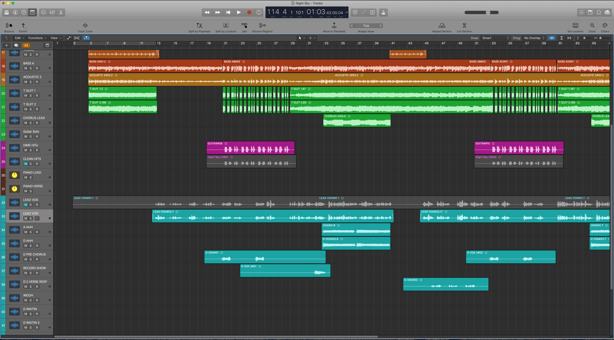
Unit 24 task 2 worksheet
DAW
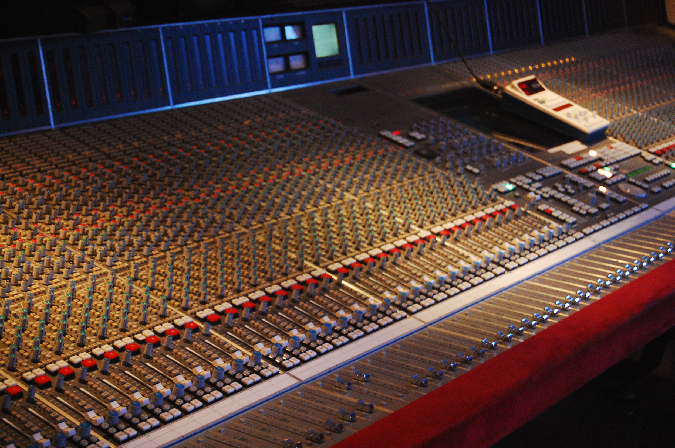
A daw stand for a digital auto software. This software is a modern software created in the 2000s. These programs work on desktops and computer software e.g. garage band and logic. It is a piece of software rather than hardware, we use logic to edit sound and professional software. Logic also runs on MACs and PCs. However it relies on the computer to do the thinking. DAWS are digital products not analogue. Logic can be licensed for £3-5 a month so it is very cheap and affordable. DAWS have a user friendly interface and mimics a mixing face and desk. Logic can be used for beginners through to professionals. When using this software you need speakers/ headphones and DAWS is a portable software meaning you take it anywhere.
MIXING DESK
a mixing desk is made up of expensive software costing up £20, 000 + that cannot be moved. the mixing desk can take up the whole room and large pieces of equipment and doesn't move. the room must be insulated and air conditioned. mixing desks are mainly used by professionals and are found in commercial recording studios. also mixing tape mixes sound together. the features that include this is that you need a master computer and separate sides and channels and a microphone. these are also equal mixes. a speaker is also needed headphones and a soundproof recording studio. you can also rent a mixing desk. professional products have been mixed and mixing desk not a DAW
CUT
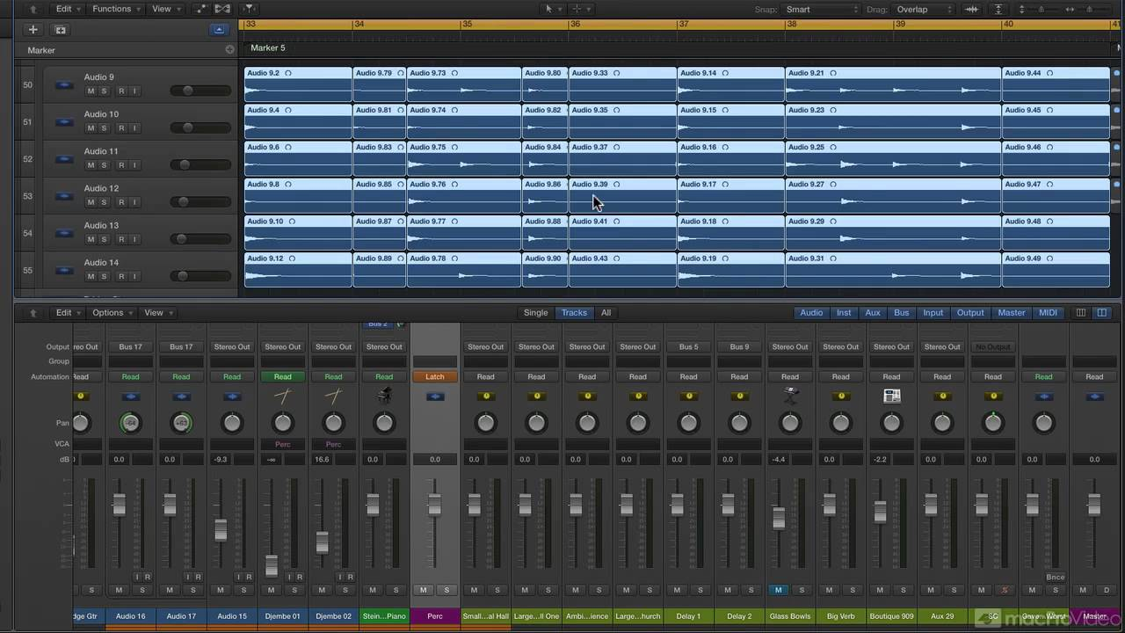
ctrl + x - we can an audio to get rid of waste ( silence & irrelevance ). by using the cut tool it can determine the length of an audio
JOIN/FADER
we can join two separate sound files by fading. if you don't crossfade we get a harsh / immediate jump between levels tone. when crossfading it can naturalise sound together
CUT AND PASTE
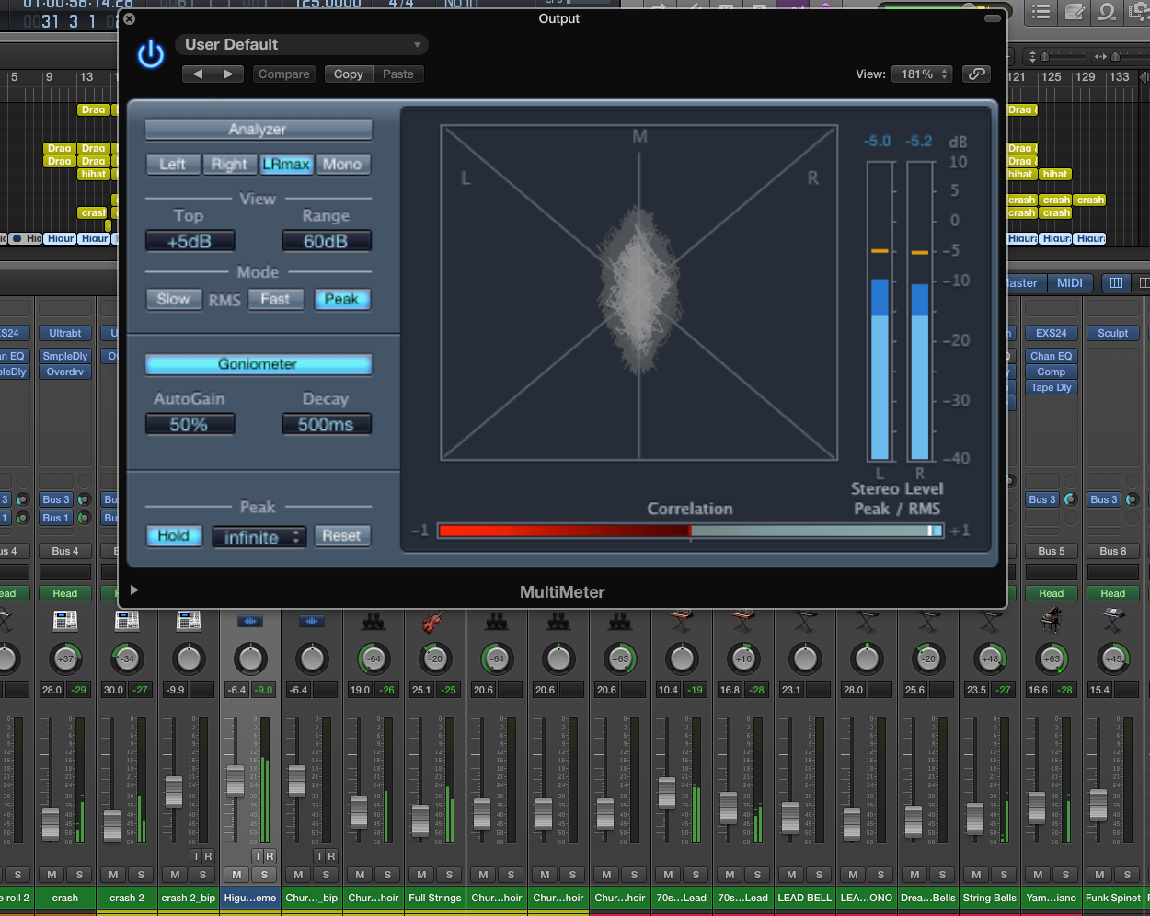
ctrl c (cut ) ctrl p (paste) - the benefits of cut and paste is that you can have the same sound at once. if you copy and paste something you can listen to the before and after editing. however the limitations of this is that you can paste the wrong thing or copy and this uses a lot of channels making the working desk look messy
STEREO FIELD
the stereo field is projected area of sound whereby you can hear music. you can push the sound around the room and control the movement of sound. we also use a stereo field to naturalise sound. it may be also used artistic effect. however the limitations of this that you need more than one speaker.
MONO
mono is sound made from one speaker and you don't need to mix this e.g. an alarm is one clear sound. a monofield is the space between the speakers
STEREO
a stereo is sound made from two speakers. these sounds are natural and makes you feel like you are in a place. you also need more than one speaker. and this needs mixing.
SOUNDBITE
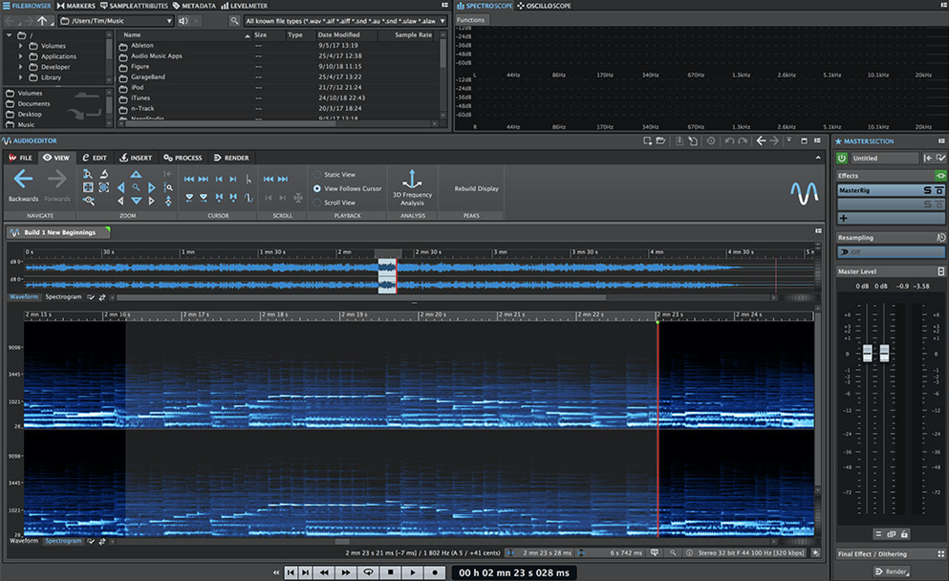
a small section from a larger recording of sound. this is often the most key and relevant of the whole. they are used to get you interested and use for a trailer. they are also used often as time restrictions of adverts/only use a snippet of this. restrictions on copyright and license and you an also copyright anything. they have to be concise and short.the limitations of this is that they can be misunderstood and misrepresentative
AUTOMATION
an automation is the same as an EQ however it has control over the selection over the mid/ high and low frequencies. there are only digital animations and no analogue. on logic it is found in the login section and can bus sound through it. it's also for doing mass jobs and can use an EQ to refine them
COLOUR CODING CLIPS
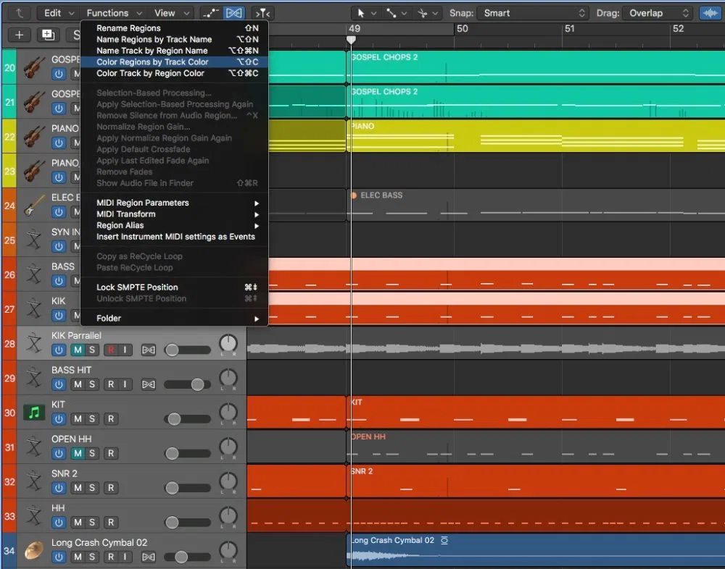
these are used to differentiate quickly between different sound files and sound sources. it also helps identify two different sounds sourcers
CLIPPING
when you a marker on a sound file. you can also colour code your marks e.g. keywords, music, key changes, drops or the end or beginning of something or a significant change
EQ
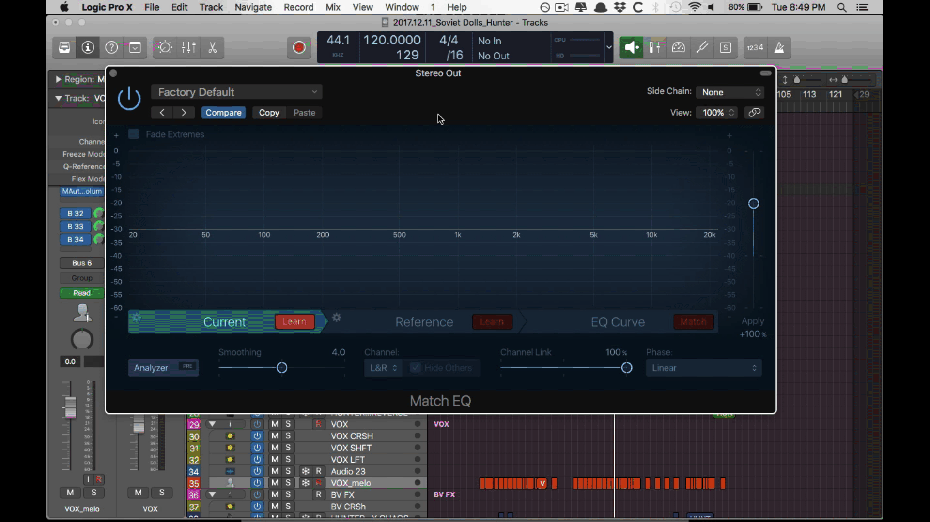
An EQ digitally edits sounds and you can control over it. it reduces the high frequency and low frequencies. this boost the middle frequencies. it increases the range of frequencies and makes them louder. on logic is known as a plugin. an EQ can bus sound through it. in an analogue mixing desk its plugin but its physical piece of hardware and contains a piece of values. we use an equaliser to naturalise sound so that our brains pick up sound in different frequencies.
PROCEDURE 1: REVIEW RECORDED MATERIAL BEFORE USING LIFE
sound editing procedure from a digital recording to an mp3 using a DAW. listening directly after you have recording it. this is the first check/ tells us if the recorder is worth editing later. this consists of a lot of products. if this procedure is followed you may not meet deadline. this may not remove ambient noise. this can also have a negative impact on the overall document. to fix this you might need to record this procedure again. another way of fixing this is by asking person to speaker slower. also get the microphone out of the wind/ put microphone close to the mouth of person
PROCEDURE 2: NAMING TRACKS AND CLIPS
procedure 2 involves taking them off the recording device. also the reason why we name tracks and clips because it is much safer to save products on a computer and this makes sure that nothing will go missing. by naming the products it makes it quicker and easier to find the tracks and clips for future uses especially if there are many tracks and some may not be identified, naming tracks is very useful. if the procedure is not followed and the tracks are not named then some tracks will be lost and will be hard and a waste of time looking for it and this may lead to a negative impact on the product

PROCEDURE 3 & 4: DRAGGING CLIPS INTO TIMELINE FOR READINESS & REPOSITIONING ORDER OF DIFFERENT SEGMENTS
the reason as to why we drag clips into a timeline for readiness is to make everything clear in a chronological order making it neater to see. the advantages e.g. if you were to recording music for a music group/ band you would have sections for the instruments and the voice so that is would be easier to separate and edit easily. this procedure also helps to order things better. overall this is will affect the product as a whole and this determines whether the product is good or bad.

THE BENEFITS OF USING KEYBOARD SHORTCUTS IN COMPARISON TO MOUSE
the benefits of using keyboard shortcuts in comparison to mouse is that this saves a lot more time such as saving work and getting things done faster in a certain amount of time.

